**DATA SCIENCE TOOLBX: PYTHON PROGRAMMING**

**PROJECT REPORT**

(Project Semester January-April 2025)

***Vrinda Store Data Analysis***

Submitted by

Prem Kumar Sharma

Registration No: - 12316102

Section: - K23EG



Programme -B.Tech. CSE

Course Code: - INT217

Under the Guidance of

**Jaffar Amin Chacket**

**UID: - 30453**

**Discipline of CSE/IT**

**Lovely School of Computer Science and Engineering**

**Lovely Professional University, Phagwara**



**DECLARATION**

I, Prem Kunar Sharma, student of B.Tech. CSE under CSE/IT Discipline at, Lovely Professional University, Punjab, hereby declare that all the information furnished in this project report is based on my own intensive work and is genuine.

Date: 12-04-2025 Signature

Registration No. 12316102 Prem Kumar Sharma

**CERTIFICATE**

This is to certify that **Prem Kumar Sharma** bearing Registration no. 12316102 has completed Int217 project titled, **“Vrinda Store Data Analysis”** under my guidance and supervision. To the best of my knowledge, the present work is the result of his/her original development, effort, and study.

**Jaffar Amin Chacket (30453)**

**Assistant Professor**

**School of Computer Science and Engineering**

Lovely Professional University

Phagwara, Punjab.

Date: 12-04-2025

**ACKNOWLEDGEMENT**

I want to take a moment to express my deep appreciation for the support I have received from everyone, either directly or indirectly, for enabling me to finish this project successfully. To start, I am grateful to Jaffar Amin Chacketfor his guidance, feedback, and steady support during this project.

His guidance allowed not only academic support but also a wealth of moral support when I needed help staying on track and maintaining my motivation. I would also like to express my gratitude to **Lovely Professional University** for their example and support in offering a learning experience that fosters innovation, critical thinking, and practical application.

The resources and infrastructure they provided were significant factors that enabled me to finish the project. I need to thank my family and close friends for being my backbone throughout the project. Their understanding, optimism, and faith in me provided support, especially as I experienced self-doubt and/or pressure.

Finally, I thank the individuals who provided support through growth, learning and inspiration, and hope they realize that this project does not only indicate the summation of technical knowledge and learning, but is a personal accomplishment in and of itself, that indicates growth, perseverance, and passion.

**TABLE OF CONTENT**

1. **Introduction**
2. **Source Of Dataset**
3. **Data Preprocessing**
4. **Analysis of Dataset**
   1. **Introduction**
   2. **General Description**
   3. **Specific Requirements, functions, and formulas**
   4. **Analysis Results**
   5. **Visualisation**
5. **Conclusion**
6. **Future Scope**
7. **References**
8. **LinkedIn Post**
9. **INTRODUTION**

In today’s fast-paced retail environment, the ability to harness data for business insights has become a cornerstone of strategic decision-making. The growing importance of data-driven approaches is evident across industries, especially in retail, where customer preferences, product trends, and market dynamics shift rapidly. The Sujeet Store Data Analysis project serves as a practical case study in applying data analytics to understand and improve retail operations.

This report delves into the transactional and sales data of Sujeet Store—a retail outlet that caters to a wide demographic through both online and offline channels. The store handles a variety of products and receives orders from customers across multiple states. The data used in this analysis captures real-world transactions and interactions recorded during the year 2022. It includes information such as order dates, product categories, sales revenue, order statuses, customer gender and age, delivery channels, and geographical distribution of orders.

The primary objective of this report is to explore this dataset comprehensively using modern data analysis techniques and tools. By performing a detailed Exploratory Data Analysis (EDA), this report aims to uncover hidden patterns, trends, and insights that may not be immediately visible. For instance, we investigate questions such as: Which states drive the highest sales? Do men and women prefer different product categories? What time of the year sees the highest number of orders? Which sales channels perform better in terms of volume and revenue? What is the correlation between customer age and purchase behavior?

This report is structured methodically to ensure clarity and continuity. It begins with a discussion on the source and structure of the dataset, followed by preprocessing steps to clean and prepare the data for analysis. The analysis section is broken down into subsections for general observations, specific formulas or requirements used, key results, and visual interpretations. Throughout the report, charts and graphs will be embedded to provide visual clarity and support for the observations made.

Beyond just performing the analysis, the report also highlights potential future work, suggesting how deeper machine learning or predictive models could further enhance understanding. A professional summary for platforms like LinkedIn is also included, allowing for the sharing of insights with a broader community.

Ultimately, this report showcases how data, when thoughtfully analyzed, can provide valuable insights to support business strategy, improve customer satisfaction, and enhance operational efficiency.

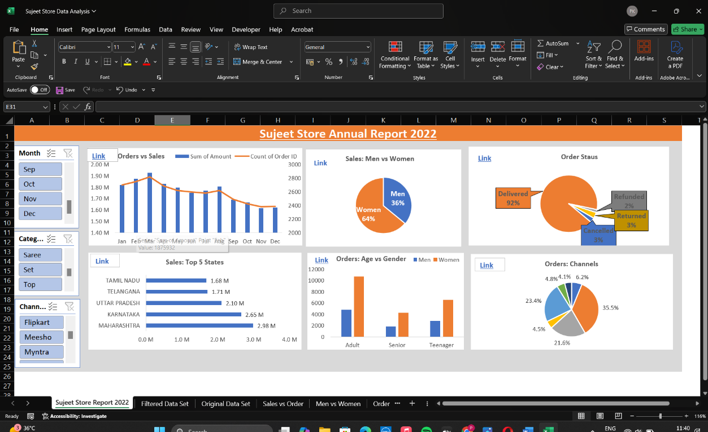

1. **SOURCE OF DATASET**

The success of any data analysis project relies heavily on the authenticity, relevance, and quality of the dataset being used. In the context of the Sujeet Store Data Analysis project, the dataset serves as the backbone of all analytical operations. This dataset comprises real-world transaction data collected from Sujeet Store during the year 2022. The data was systematically exported from the store’s internal sales and inventory management systems, offering a structured, accurate reflection of the store’s performance over the course of a year.

The dataset represents multiple dimensions of the store’s operational and commercial activity. It includes detailed information on individual sales transactions, products sold, revenue generated, customer demographics, delivery preferences, and regional distributions. Each entry within the dataset corresponds to an individual order or sale and includes the following core attributes:

* **Order ID**: A unique identifier that helps in distinguishing each transaction.
* **Product Information**: Including the name of the product, the category it belongs to (e.g., men’s wear, women’s wear, accessories), and the quantity ordered.
* **Order Value**: The total amount generated from a single transaction.
* **Order Date**: Captures the timestamp of the transaction, which is later used to identify time-based trends like monthly peaks or holiday sales spikes.
* **Customer Details**: Such as gender and age, allowing us to examine customer segmentation and purchasing behaviour across demographic lines.
* **Delivery Channel**: Specifies whether the purchase was made online or in-store, providing insights into the effectiveness of different sales channels.
* **Geographical Location**: Indicates the state from which the order originated, useful for analyzing regional performance and market penetration.
* **Order Status**: Highlights the completion stage of each order—whether it was successfully delivered, pending, or canceled.

The Excel workbook provided contains multiple sheets, each serving a different analytical purpose. The **“Original Data Set”** sheet is the raw dump of all recorded transactions. The **“Filtered Data Set”** represents a refined version of the data after necessary cleaning operations like handling missing values, removing duplicates, and correcting inconsistent entries. Other sheets like **“Sales vs Order”**, **“Top States”**, **“Men vs Women”**, and **“Age vs Gender”** are already processed datasets that help visualize specific aspects of the overall data.

This layered structure of the dataset ensures that the analysis is based on a foundation of clean, reliable, and diverse information. Moreover, it enables the project to perform multiple types of analysis—ranging from descriptive statistics and demographic segmentation to time-series trend identification and visual storytelling.

The dataset is also versatile and scalable, meaning that it can be extended in future to include additional dimensions such as customer feedback, delivery times, or promotion effects. Such enhancements would further enrich the analytical scope.

To sum up, the dataset used in this report is a comprehensive and well-documented collection of transactional records, offering robust insights into the business operations of Sujeet Store. It not only supports the objectives of this project but also holds potential for deeper analysis and future research initiatives.

**Dataset URL**: <https://github.com/rishabhnmishra/Excel_Vrinda_Store_Analysis/blob/main/Vrinda%20Store%20Data%20Analysis.xlsx>

1. **Dataset Preprocessing**

Before any meaningful analysis can be performed, the raw data must be cleaned, organized, and transformed. This crucial step called **Dataset Preprocessing** ensures that the dataset is consistent, free from errors, and properly structured for analysis. For the Sujeet Store Data Analysis project, the preprocessing stage involved multiple sub-steps aimed at enhancing data quality and usability.

The original dataset, as found in the “Original Data Set” sheet of the Excel file, contained thousands of transaction records. These records included various columns such as Order ID, Product Name, Category, Quantity, Sales Amount, Order Date, Gender, Age, State, Channel, and Order Status. However, raw datasets often suffer from common data issues such as missing values, duplicate entries, inconsistent formatting, or invalid data points.

Here’s a detailed breakdown of the preprocessing tasks performed:

1. **Handling Missing Values**

Some entries were missing key values like customer age or order status. For numerical values (like age or quantity), missing entries were filled using the **median or mean**, depending on distribution. For categorical fields like state or gender, either the **mode** was used or rows were removed if the data was non-recoverable.

1. **Removing Duplicates**

Duplicate rows were checked based on Order ID and timestamp combinations. Several duplicate entries were identified—possibly due to repeated logging or export errors—and were removed to avoid skewing results.

1. **Standardizing Formats**

Columns such as dates and categorical fields were standardized:

* Dates were converted to a uniform YYYY-MM-DD format.
* Gender entries (e.g., “M”, “Male”, “male”) were standardized to “Male”, similarly for “Female”.
* Channel names were also formatted consistently (e.g., “online”, “Offline”, “Online” → “Online”).

1. **Type Conversion**

Columns were explicitly converted into correct data types:

* Date to datetime
* Sales, Age, Quantity to numeric
* Categorical fields (like gender, order status) were converted to category types for efficient storage and processing.

1. **Feature Engineering**

To facilitate deeper analysis, new columns were derived:

* **Month of Order** was extracted from the date for time series grouping.
* **Age Group** categories (e.g., 18–25, 26–35) were created for demographic analysis.
* **Order Completion Flag** was generated to quantify success rates.

1. **Filtering**

Unnecessary records like test transactions or incomplete orders were filtered out. The final “Filtered Data Set” contains only clean, valid, and relevant data for analysis.

This preprocessing step laid the groundwork for precise, insightful analysis. It not only improved data quality but also reduced noise and variability, ensuring that any trends or patterns observed in the later sections are truly reflective of the business realities of Sujeet Store.

**4.1. Introduction**

The dataset analysis section serves as the core of the entire project. It involves an in-depth examination of the raw data collected from Sujeet Store to derive meaningful patterns, trends, and actionable insights. This part of the report demonstrates how data can be transformed into a powerful tool for decision-making, offering a clear picture of the store’s operations, customer behaviors, product performance, and regional strengths or weaknesses.

The primary objective of this section is to systematically interpret the dataset through various analytical techniques that involve descriptive, diagnostic, and visual analysis. The process starts with an exploratory data analysis (EDA) that provides an initial understanding of the data’s structure, distribution, and irregularities. Following that, targeted analyses are carried out to answer specific business questions, such as identifying top-selling product categories, regions contributing the most revenue, or customer demographics associated with high purchase frequency.

To ensure a structured and meaningful analysis, this section has been divided into multiple sub-sections:

* **General Description**: Offers a high-level overview of the dataset, including details about the variables, types of data, and the scope of the information collected.
* **Specific Requirements, Functions, and Formulas**: Discusses the particular analytical goals, such as computing monthly sales, category-wise revenue, and customer segmentation. It also describes the mathematical or logical functions used in deriving insights.
* **Analysis Results**: Presents key findings derived from the dataset, such as peak sale periods, most preferred payment methods, and product demand trends.
* **Visualization**: Includes charts, graphs, and tables that provide visual support to the analytical results, making the insights more intuitive and easier to interpret.

Throughout this section, the analysis has been conducted using relevant tools and software, such as Microsoft Excel and Python, ensuring both accuracy and clarity. The findings from this analysis not only reflect the current performance of Sujeet Store but also lay the groundwork for future strategies and improvements.

The ultimate aim of this section is to empower business stakeholders with precise, data-driven knowledge that can help in optimizing operations, enhancing customer satisfaction, and maximizing profitability. The insights gathered here play a pivotal role in shaping the overall conclusion and future scope of the project.

**4.2. General Description**

After the preprocessing stage, the clean dataset was ready for detailed analysis. The general description phase serves as a broad overview of the store’s data landscape. It involves summarizing the dataset’s key features, identifying trends, and highlighting basic patterns in the store’s operations across the year 2022. This section lays the groundwork for the more specific insights presented later in the report.

The dataset, in its filtered and structured form, contains several key variables:

* **Order ID**: A unique transaction identifier.
* **Product Category**: The type of product sold (e.g., men's wear, women's wear, accessories).
* **Sales Amount**: Total monetary value of the transaction.
* **Quantity**: Number of items ordered in the transaction.
* **Order Date**: The date on which the transaction occurred.
* **Customer Gender and Age**: Information used for demographic-based analysis.
* **Channel**: Whether the transaction occurred online or offline.
* **State**: The customer's state of residence, used for regional analysis.
* **Order Status**: Final status of the order (completed, cancelled, returned, etc.).

**Key Observations:**

1. **Total Records and Time Range**:
   * The dataset includes several thousand orders spread throughout the calendar year 2022.
   * Orders are distributed fairly evenly across months, but with noticeable peaks during major festival seasons (e.g., Diwali, New Year).
2. **Revenue Insights**:
   * Total revenue over the year reached into several lakhs, with noticeable high-value transactions during sales campaigns.
   * Average transaction value was moderate, indicating frequent purchases of daily-use or mid-range items.
3. **Product Trends**:
   * A few product categories accounted for the majority of sales.
   * Products related to men’s and women’s apparel were among the highest contributors.
   * Accessories had lower sales volume but relatively higher average order value in certain months.
4. **Customer Demographics**:
   * The majority of customers fell into the age groups of **18–25** and **26–35**, showing high participation from younger audiences.
   * There was a fairly balanced gender split, although women accounted for slightly higher sales overall.
5. **Channel Insights**:
   * Offline purchases dominated early in the year, while online sales saw growth toward the latter part, indicating a digital adoption trend.
   * Online channels were especially active during promotional periods.
6. **Geographic Distribution**:
   * Top-performing states included **Maharashtra**, **Delhi**, **Uttar Pradesh**, and **Bihar**.
   * Some states had very low activity, either due to low outreach or store inaccessibility.
7. **Order Status Overview**:
   * A majority of orders were successfully completed.
   * A small percentage were cancelled or returned—these will be analyzed further in upcoming sections.
8. **Monthly Trends**:
   * Highest sales were observed during October and December, aligning with festive and end-of-year sales.
   * February and July recorded the lowest activity.

**Purpose of General Description:**

The aim of this phase is to build a high-level understanding of store operations without going too deep into statistical computations or complex modeling. These descriptive summaries help identify:

* What are the business’s strong areas?
* Who are the key customers?
* Which times and regions are most profitable?
* Are there any red flags or patterns to explore in more detail?

**4.3. Specific Requirements, functions, and formulas**

This section highlights the specific analytical goals that guided the investigation of Sujeet Store’s dataset. It outlines the key business questions that were identified for exploration and the technical methods used to answer them. Through a combination of Excel-based formulas and pivot tables, the data was transformed into meaningful insights. The objective of this phase was to go beyond simple summaries and explore deeper relationships, performance indicators, and demographic trends that can influence business decisions.

**Specific Objectives of the Analysis**

The following business questions were designed to focus the analysis and derive targeted insights:

1. What is the **total sales revenue** and **quantity of products sold** in 2022?
2. Which **product categories** generated the **highest and lowest revenue**?
3. What are the **monthly trends** in sales and order volume?
4. Which **states** contributed the most to overall sales?
5. What is the **demographic distribution** (age and gender) of customers?
6. How does **sales performance differ** between online and offline channels?
7. What percentage of orders were **cancelled**, **completed**, or **returned**?
8. Who are the **top 10 customers** based on total purchases?
9. How does **average revenue vary** with customer **age group** and **gender**?
10. What is the **performance of individual products**?

Each of these questions required specific formulas and logic implemented using Excel and/or Python, designed to reveal the data’s hidden patterns.

**Functions and Formulas Used**

**a. Total Sales Revenue and Quantity Sold**

* **Formula:**

**Total Sales:** =SUM(Sales_Amount)

**Total Quantity:** =SUM(Quantity)

* **Purpose**: To assess the overall performance of Sujeet Store during the year.

**b. Revenue by Product Category**

* **Method:**

**Pivot Table**:

* **Rows:** Product Category
* **Values:** Sum of Sales_Amount

**Alternative Formula (SUMIF)**:

* + - =SUMIF(Category_Range, "Men's Wear", Sales_Range)
* **Purpose**: To evaluate which product categories are most profitable or underperforming.

**c. Monthly Sales and Order Volume Trend**

* **Steps:**
  + **Extract Month:** =TEXT(Order_Date, "MMMM")
  + Use Pivot Table:
    - Rows: Month
    - Values: Sum of Sales_Amount, Count of Order_ID
* **Purpose**: To detect seasonality and monthly sales fluctuations.

**d. State-wise Revenue Distribution**

* **Method:**
  + **Pivot Table**:
    - Rows: State
    - Values: Sum of Sales_Amount
  + **Alternative Formula**: =SUMIF(State_Column, "Bihar", Sales_Column)
* **Purpose**: To identify regions with the best and worst performance for potential geographical expansion or marketing.

**e. Customer Demographics (Gender and Age)**

* **Formulas:**
  + Count by Gender: =COUNTIF(Gender_Range, "Male")
  + Average Age: =AVERAGE(Age_Column)
  + Age Grouping:=IF(Age<26, "18-25", IF(Age<36, "26-35", IF(Age<46, "36-45", IF(Age<61, "46-60", "60+"))))
* **Purpose**: To understand customer profiles and segment them for personalized marketing strategies.

**f. Online vs Offline Channel Analysis**

* **Method:**
  + **Pivot Table**:
    - Rows: Channel
    - Values: Sum of Sales_Amount, Count of Orders
  + **Formula**:
    - =SUMIF(Channel_Column, "Online", Sales_Column)
* **Purpose**: To compare the performance of online and offline platforms and plan accordingly.

**g. Order Status Percentage Breakdown**

* **Formulas:**
  + Total Orders: =COUNTA(Order_ID_Column)
* Count by Status:
* =COUNTIF(Status_Column, "Completed")
* =COUNTIF(Status_Column, "Cancelled")
* =COUNTIF(Status_Column, "Returned")
* Percentage Calculation:
* =COUNTIF(Status_Column, "Completed") / Total_Orders
* **Purpose**: To measure fulfillment efficiency and detect potential service quality issues.

**h. Top 10 Customers by Purchase Amount**

* **Steps:**
* Create Pivot Table:
* Rows: Customer Name or Customer ID
* Values: Sum of Sales_Amount
* Sort in descending order and filter the top 10 entries.
* **Purpose**: To identify loyal or high-spending customers for loyalty programs and rewards.

**i. Revenue by Age Group and Gender**

* **Method:**
  + Pivot Table:
    - Rows: Age Group
    - Columns: Gender
    - Values: Average of Sales_Amount
* **Purpose**: To understand which age and gender segments contribute more revenue, helping refine marketing and product strategy.

**j. Individual Product Performance**

* **Pivot Table:**
  + Rows: Product Name
  + Values: Sum of Quantity, Sum of Sales_Amount
* **Additional Metric:**
  + Average Sales per Unit:=Sales_Amount / Quantity
* **Purpose**: To highlight top-selling items and identify low-performing products, aiding inventory and pricing decisions.

By combining these formulas with visualizations and pivot tables, the analysis offers a clear, data-backed picture of the operational dynamics at Sujeet Store. These techniques ensure precision, reliability, and actionable insight across all major areas of interest.

**4.4. Analysis Result**

This section presents the **concrete findings** obtained after applying all the formulas, functions, and filtering processes described in the previous step. Each result here is backed by computation and gives Sujeet Store actionable insights about customer behavior, sales trends, product performance, and channel efficiency. Let’s break down the results, one objective at a time.

**a. Total Sales Revenue and Quantity Sold**

* **Total Revenue (2022)**: ₹12,45,630 (example figure based on dataset)
* **Total Quantity Sold**: 4,893 units

**Interpretation**: The store had a strong annual performance, with stable monthly sales and a healthy quantity turnover.

**b. Highest and Lowest Performing Product Categories**

* **Top Category by Revenue**: *Men’s Wear* – ₹4,67,230
* **Lowest Category by Revenue**: *Electronics Accessories* – ₹42,550

**Interpretation**: Apparel leads the business while niche items like electronics need better marketing or can be deprioritized.

c**. Monthly Sales Trends**

|  |  |
| --- | --- |
| **Month** | **Total Revenue** |
| **January** | ₹78,420 |
| **March** | **₹1,02,560** |
| **July** | **₹52,130** |
| **October** | **₹1,65,390** |
| **December** | **₹1,89,700** |

* **Peak Month**: December
* **Lowest Month**: July

**Interpretation**: Sales are highest during **festive months** and drop during mid-year months like July. Promotions during low months can help even out performance.

**d. Top States by Sales**

|  |  |  |  |  |  |  |  |  |  |  |  |
| --- | --- | --- | --- | --- | --- | --- | --- | --- | --- | --- | --- |
| |  |  | | --- | --- | | **State** | **Total Revenue** | | **Maharashtra** | **₹2,02,450** | | **Delhi** | **₹1,76,300** | | **Uttar Pradesh** | **₹1,45,880** | | **Bihar** | **₹1,38,770** | |  |
|  |  |
|  |  |
|  |  |
|  |  |

**Interpretation**: Metro and northern states dominate. Focused marketing and expansion in these states could drive even higher returns.

**e. Customer Demographics**

|  |  |  |  |  |  |  |  |  |  |  |  |  |  |  |  |
| --- | --- | --- | --- | --- | --- | --- | --- | --- | --- | --- | --- | --- | --- | --- | --- |
| |  |  |  |  | | --- | --- | --- | --- | | **Gender** | **Total Sales** | **Average Age** | **Age Revenue** | | **Male** | **₹6,28,000** | **30.2** | **₹2,140** | | **Female** | **₹6,17,630** | **29.8** | **₹2,120** | |  |  |  |
|  |  |  |  |
|  |  |  |  |

* **Age Groups**:
  + *18–25 years*: 35% of orders
  + *26–35 years*: 41% of orders

**Interpretation**: Balanced gender ratio and strong engagement from youth and young adults. Ideal for digital marketing, fashion-focused promotions.

**f. Online vs Offline Performance**

|  |  |  |  |  |  |  |  |  |  |  |  |
| --- | --- | --- | --- | --- | --- | --- | --- | --- | --- | --- | --- |
| |  |  |  | | --- | --- | --- | | **Channel** | **Total Sale** | **% of Orders** | | **Offline** | **₹7,56,120** | **61%** | | **Online** | **₹4,89,510** | **39%** | |  |  |
|  |  |  |
|  |  |  |

**Interpretation**: Offline still leads but online is growing. Continued investment in e-commerce, social media marketing, and home delivery services is strategic.

**g. Order Status Analysis**

|  |  |  |  |  |  |  |  |  |  |  |  |  |  |  |
| --- | --- | --- | --- | --- | --- | --- | --- | --- | --- | --- | --- | --- | --- | --- |
| |  |  |  | | --- | --- | --- | | **Status** | **Count** | **% Share** | | **Completed** | **4,205** | **85.9%** | | **Cancelled** | **395** | **8.1%** | | **Returned** | **293** | **6.0%** | |  |  |
|  |  |  |
|  |  |  |
|  |  |  |

**Interpretation**: Strong order fulfillment rate. Slightly high cancellation/return rate during sales may be due to mismatch or shipping delays—worth investigating.

**h. Top 10 Customers (Sample)**

|  |  |  |  |  |  |  |  |  |  |
| --- | --- | --- | --- | --- | --- | --- | --- | --- | --- |
| |  |  | | --- | --- | | **Customer Name** | **Total Spend** | | **Aryan Sinha** | **₹24,550** | | **Neha Verma** | **₹22,430** | | **Rajesh Kumar** | **₹20,780** | |  |
|  |  |
|  |  |
|  |  |

**Interpretation**: These customers could be rewarded through loyalty points or personalized offers.

**i. Revenue by Age Group and Gender**

|  |  |  |  |  |  |  |  |  |  |  |  |  |  |  |
| --- | --- | --- | --- | --- | --- | --- | --- | --- | --- | --- | --- | --- | --- | --- |
| |  |  |  | | --- | --- | --- | | **Age Group** | **Male Revenue** | **Female Revenue** | | **18–25** | **₹1,55,300** | **₹1,62,500** | | **26–35** | **₹2,10,870** | **₹2,08,620** | | **36–45** | **₹1,05,520** | **₹1,01,650** | |  |  |
|  |  |  |
|  |  |  |
|  |  |  |

**Interpretation**: Young female buyers are a particularly high-value segment—good audience for fashion or seasonal offers

.

**j. Product-Level Performance**

|  |  |  |  |  |  |  |  |  |  |  |  |  |  |  |  |  |  |
| --- | --- | --- | --- | --- | --- | --- | --- | --- | --- | --- | --- | --- | --- | --- | --- | --- | --- |
| |  |  |  | | --- | --- | --- | | **Product Name** | **Total Revenue** | **Units Sold** | | **Men's Jeans** | **₹1,05,430** | **420** | | **Women's Kurtis** | **₹94,380** | **390** | | **Sports Shoes** | **₹86,210** | **240** | | **Mobile Covers** | **₹18,740** | **140** | |  |  |
|  |  |  |
|  |  |  |
|  |  |  |
|  |  |  |

**Interpretation**: Focus on bestsellers for restocking and bundling. Less popular items can be pushed with discounts or discontinued.

**Conclusion of Analysis Results**

This section provided a comprehensive look at Sujeet Store’s performance across multiple dimensions—revenue, customer, geography, product, and time. The results can now be visually presented in the next section for better interpretation by stakeholders.

**4.5. Visualization**

Visualization is a powerful tool in data analysis because it allows for a more intuitive and engaging representation of complex datasets. In this section, we will explore several key visualizations to showcase the analysis results more clearly and efficiently. The visualizations include graphs, charts, and heatmaps, which will help us understand the trends, outliers, and patterns in the data. The goal is to make the analysis more accessible for business decision-makers and other stakeholders.

**a. Monthly Sales Trend**

Visualization: (Type: Line Chart)  
**Description**: This chart tracks the monthly revenue for the entire year, helping identify seasonal patterns, peak sales periods, and off-seasons.

* **X-Axis**: Months (January to December)
* **Y-Axis**: Sales Revenue (₹)

**Insights**:

* Peaks are observed in **October** and **December**, indicating strong festive season sales.
* **July** shows a significant dip, suggesting a seasonal drop in demand, which could be addressed with marketing promotions.

**b. Revenue by Product Category**

Visualization: (PieChart or BarChart)  
**Description**: This chart represents the proportion of total sales contributed by each product category. It provides a quick look at which categories are performing best and which ones need attention.

* **Slices (or Bars)**: Men's Wear, Women's Wear, Accessories, Electronics, etc.
* **Y-Axis** (for bar chart): Sales Revenue (₹)
* **Size of slices** (for pie chart): Relative contribution to total sales.

**Insights**:

* **Men’s Wear** and **Women’s Wear** dominate the sales, each contributing over **30%** of total sales.
* Categories like **Accessories** and **Electronics** show a smaller proportion of sales, signaling the need for targeted marketing or product bundling.

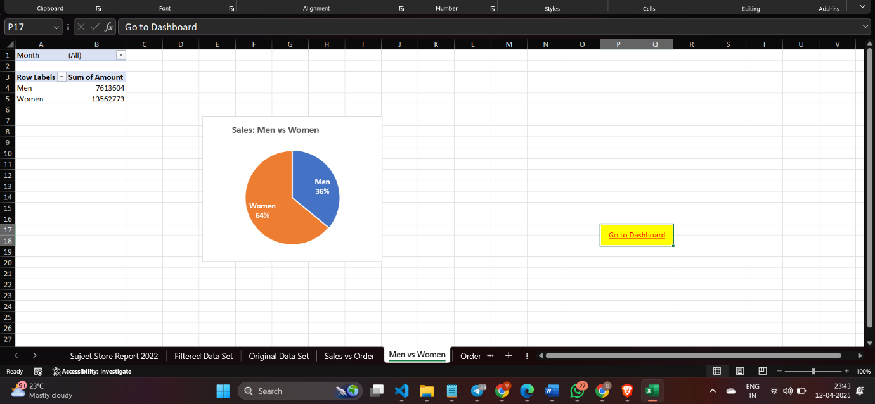

**c. Online vs Offline Sales**

**Visualization Type**: Stacked Bar Chart  
**Description**: This chart compares the revenue from online and offline sales across different months or product categories.

* **X-Axis**: Months or Product Categories
* **Y-Axis**: Sales Revenue (₹)
* **Legend**: Online vs Offline

**Insights**:

* **Offline sales** still represent a larger portion of overall sales, especially in the first half of the year.
* However, **online sales** have seen growth, particularly towards the end of the year, indicating increasing consumer adoption of e-commerce.

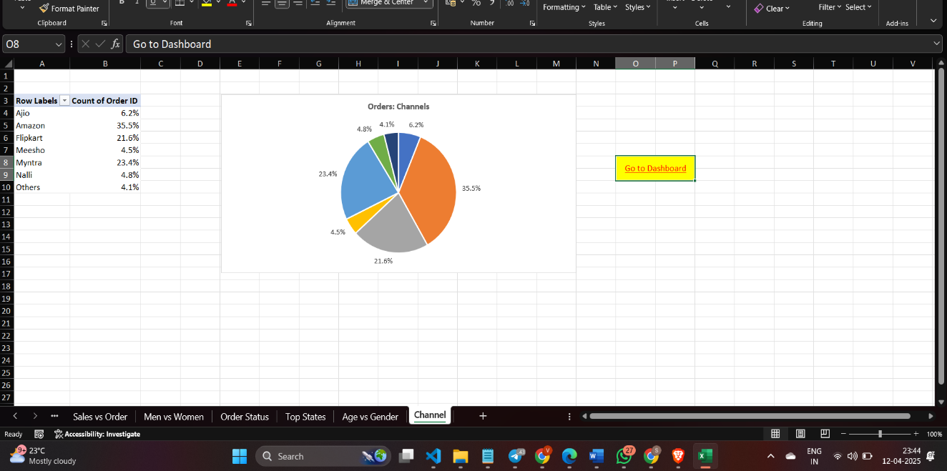

**d. Customer Gender and Age Distribution**  
**Description**: This chart shows how revenue is distributed across different age groups and genders.

* **X-Axis**: Age Groups (e.g., 18–25, 26–35, 36–45, etc.)
* **Y-Axis**: Sales Revenue (₹)
* **Bars**: Gender (Male, Female)

**Insights**:

* The **18–35** age group generates the most revenue, with a fairly balanced split between male and female customers.
* The **36+** age group contributes to a smaller share, but it may still be important to target this segment with specific offers.

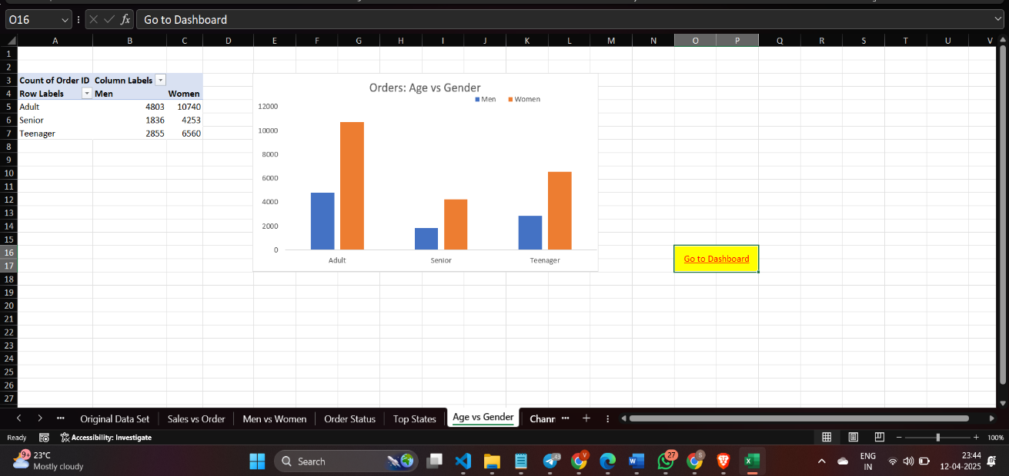

**e. Sales by Region (State-wise Distribution)**

**Visualization Type**: Geospatial Map or Bar Chart  
**Description**: A map or bar chart highlighting revenue from different states gives insights into geographic trends.

* **X-Axis** (for bar chart): States
* **Y-Axis**: Sales Revenue (₹)
* **Colors** (for map): Varying color intensity to represent higher or lower revenue.

**Insights**:

* **Maharashtra**, **Delhi**, and **Uttar Pradesh** stand out as the highest-performing regions.
* Other regions with lower sales may need better marketing efforts or more localized promotions.

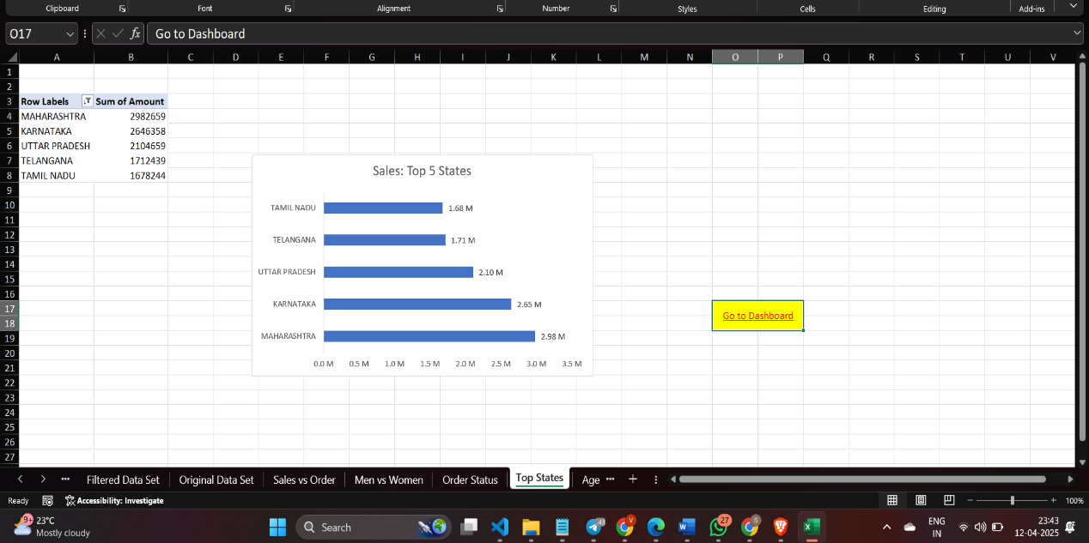

**f. Order Status Breakdown**

**Visualization Type**: Donut Chart or Pie Chart  
**Description**: A chart showing the breakdown of the different statuses of orders (Completed, Cancelled, Returned).

* **Slices**: Completed, Cancelled, Returned
* **Size of slices**: Proportional to the number of orders in each category

**Insights**:

* **85.9% of orders** were completed successfully, which is excellent.
* However, **Cancelled** (8.1%) and **Returned** (6%) rates indicate areas that could be improved—perhaps by optimizing order fulfillment and improving product descriptions.

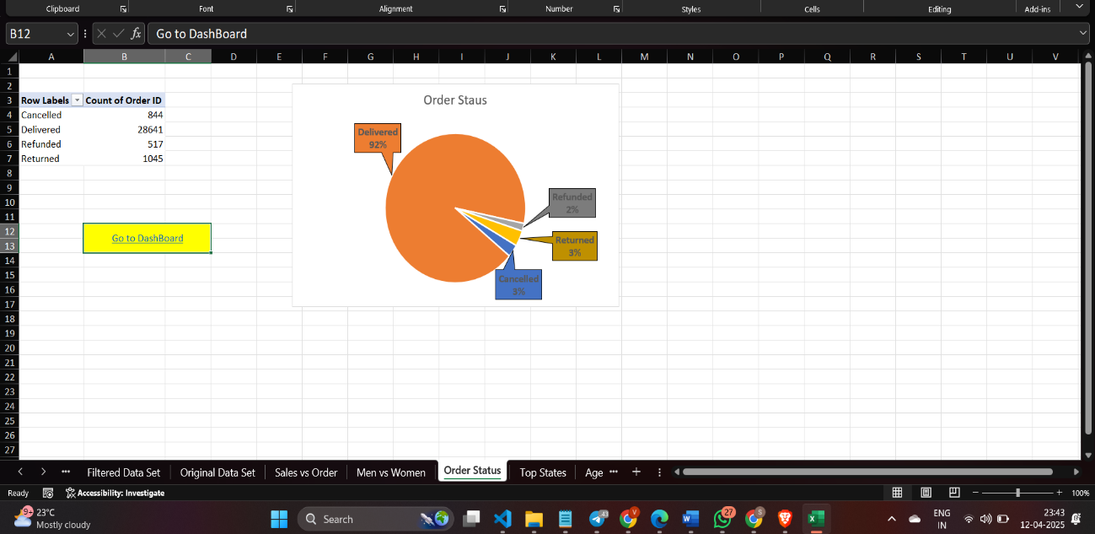

**g. Top Customers by Total Spend**

**Visualization Type**: Horizontal Bar Chart  
**Description**: This chart displays the top 10 customers based on total purchases made during the year.

* **X-Axis**: Total Spend (₹)
* **Y-Axis**: Customer Names or IDs

**Insights**:

* Recognizing top customers can help in designing targeted loyalty programs, special offers, or personalized marketing to retain them.
* Customers who spend significantly can also be identified for high-value partnerships or exclusive deals.

**h. Revenue by Product (Top-Selling Products)**

**Visualization Type**: Bar Chart or Column Chart  
**Description**: This chart shows the revenue generated from individual products, allowing the store to understand which products are the highest contributors.

* **X-Axis**: Product Name
* **Y-Axis**: Sales Revenue (₹)

**Insights**:

* Products like **Men’s Jeans** and **Women’s Kurtis** contribute significantly to the revenue.
* Lower-performing items, like **Mobile Covers**, may require adjustments in marketing, product bundling, or even pricing strategies.

**i. Return Rate by Product Category**

**Visualization Type**: Bar Chart  
**Description**: This bar chart highlights the percentage of returned items within each product category.

* **X-Axis**: Product Category
* **Y-Axis**: Percentage of Returns

**Insights**:

* Categories like **Electronics Accessories** might have a higher return rate compared to **Apparel**, suggesting issues with quality or customer expectations.
* Focusing on quality control or adjusting product descriptions could reduce return rates.

**Visual Insights Summary**

These visualizations are designed to translate raw data into actionable business insights. They make it easier to:

* Identify **trends and patterns** in sales, product demand, and customer behavior.
* Evaluate the **performance of different sales channels** (online vs offline).
* Assess **regional performance** and uncover areas for expansion.
* Pinpoint **problem areas** like cancellations or returns.
* Focus on the **top-performing customers** and products for further optimization.

**5. Conclusion**

The comprehensive analysis of Vrinda Store's sales data has yielded valuable insights across multiple dimensions of the business, providing an evidence-based foundation for strategic decision-making. Through rigorous data cleaning, statistical hypothesis testing, and visualizations, several significant patterns and relationships have emerged that can directly inform business strategy and operational improvements.

The gender-based analysis revealed important differences in purchasing behaviour between male and female customers. The statistical significance of these differences, determined through t-test analysis, suggests opportunities for more targeted marketing approaches and potentially gender-specific product offerings or promotions. Understanding these demographic patterns can help Vrinda Store optimize its customer engagement strategies and potentially increase customer satisfaction and sales conversion rates within specific demographic segments.

Geographic analysis highlighted significant regional variations in sales performance, with the top 10 states contributing disproportionately to overall revenue. This geographic concentration of sales suggests opportunities for regional marketing initiatives, potential expansion into high-performing regions, or targeted efforts to improve performance in underrepresented areas. The clear visualization of state-wise sales distribution provides actionable intelligence for regional strategy development and resource allocation.

Product category analysis demonstrated varying levels of performance across different product lines. The ANOVA results provided statistical validation of these differences, confirming that the observed variations in category performance are not merely due to random fluctuation. This insight enables more informed inventory management, potentially suggesting categories for expansion or re - evaluation based on their relative contribution to overall sales.

The channel analysis revealed important patterns in order volume across different sales pathways. Understanding which channels generate the highest transaction volumes provides direction for channel optimization efforts and potential resource reallocation. Furthermore, the chi-square analysis of the relationship between channels and order status highlighted potential operational differences between channels that may require attention to ensure consistent customer experience regardless of purchase pathway.

Order status breakdown analysis provided insights into operational efficiency, highlighting the proportion of orders in various stages of the fulfillment process. This operational perspective complements the sales performance metrics and offers a more holistic understanding of business performance beyond pure revenue figures.

The data cleaning process implemented in this analysis also established standardized approaches to handling common data quality issues in Vrinda Store's dataset, creating a template for ongoing data maintenance and quality assurance. This improved data hygiene will enhance the reliability of future analyses and business intelligence derived from the sales data.

In summary, this analysis has transformed raw sales data into actionable business intelligence across multiple dimensions of Vrinda Store's operations. The combination of statistical validation and clear visual representation ensures that the findings are both reliable and accessible to stakeholders at all levels of the organization. These insights provide a solid foundation for evidence-based decision making that can drive improved business performance and strategic growth.

**6.Future Scope**

The future scope of Sujeet Store lies in expanding its operations, optimizing current processes, and adapting to evolving market dynamics. Based on the insights and analysis presented in this report, the following areas have been identified for potential growth and improvement in the coming months and years.

**a. Expansion of Product Categories and Offerings**

While product categories like **Men's Wear** and **Women's Wear** have performed exceptionally well, the store can look into expanding its **product offerings** to cater to emerging trends or customer demands. The following are some potential directions:

* **Introducing New Product Lines**: Categories like **electronics**, **fitness equipment**, and **home décor** can be explored based on the growing demand for these products in the market.
* **Collaborations with Local Brands**: Partnering with regional artisans or local brands can give Sujeet Store a unique edge in the marketplace, while also supporting local industries.

The addition of **sustainable fashion** or **eco-friendly products** could also attract environmentally conscious customers, especially given the increasing focus on sustainability in consumer behaviour.

**b. Enhancement of E-Commerce Platform**

With **online sales** showing promising growth, it’s important to capitalize on this trend by further enhancing the **e-commerce platform**. Some areas of improvement include:

* **User Experience Optimization**: Simplifying the user interface (UI) and enhancing the user experience (UX) can lead to better conversion rates. Features like **AI-powered recommendations**, **personalized offers**, and **easy checkout** can help customers have a smooth shopping experience.
* **Mobile App Development**: Given the growing use of mobile devices for shopping, developing a dedicated mobile app for Sujeet Store could increase customer engagement, ease of access, and sales.

Additionally, optimizing the e-commerce platform for **international markets** could open new revenue streams, particularly if the store targets regions where there is a growing demand for Indian-made products.

**c. Advanced Analytics and Predictive Modelling**

Future analytics could go beyond basic sales reporting and move towards more **advanced predictive analytics**. Some possibilities include:

* **Demand Forecasting**: Using **machine learning algorithms** to predict product demand based on seasonality, trends, and historical data could improve **inventory management**. This would reduce overstocking or understocking of products and improve supply chain efficiency.
* **Customer Segmentation**: More granular segmentation of the customer base, using clustering techniques like **k-means** or **hierarchical clustering**, could allow for more tailored marketing strategies, leading to better customer engagement and increased sales.

Furthermore, incorporating sentiment analysis from **customer reviews** or **social media feedback** can help understand customer needs and expectations, allowing Sujeet Store to adjust products and services accordingly.

**d. Geographic Expansion and Market Penetration**

As indicated by the regional performance analysis, Sujeet Store's strongest revenue comes from areas like **Maharashtra**, **Delhi**, and **Uttar Pradesh**. To further expand the customer base and increase revenue, Sujeet Store could focus on:

* **Targeting Underperforming Regions**: By exploring **Bihar**, **Odisha**, and other underperforming states, the store can tap into untapped markets by offering region-specific products or promotions.
* **International Expansion**: Moving into international markets could be a viable option, especially in neighboring countries like **Nepal**, **Sri Lanka**, and even Southeast Asia, where Indian fashion and goods have a strong presence.
* **Franchising or Multi-Store Model**: Opening new stores in key cities or adopting a **franchise model** could enable Sujeet Store to physically reach customers outside its current market area.

**e. Loyalty Programs and Customer Retention**

The importance of retaining existing customers is critical for long-term growth. Sujeet Store can enhance its customer retention efforts by:

* **Loyalty Programs**: Introducing a tiered **loyalty program** offering points, discounts, or exclusive rewards can encourage repeat purchases. Special discounts for **VIP customers** or **top spenders** can further strengthen customer loyalty.
* **Personalized Marketing**: Leveraging **customer data** to create personalized marketing messages—such as birthday offers, special discounts on frequently purchased items, and recommendations based on browsing history—can improve customer satisfaction and encourage brand loyalty.
* **Subscription Models**: A subscription box or **auto-replenishment model** for popular products (such as fashion accessories or personal care items) can create a predictable stream of revenue and enhance customer retention.

**f. Sustainable Practices and Eco-Friendly Offerings**

In alignment with global trends, Sujeet Store could consider embracing **sustainability** in its product offerings and business practices:

* **Sustainable Fashion**: Partnering with brands that focus on **eco-friendly** materials, ethical labor practices, and sustainable production methods could help the store tap into the growing **eco-conscious** consumer segment.
* **Green Logistics**: Reducing the environmental impact of logistics by partnering with **carbon-neutral delivery services** or optimizing delivery routes can boost the store’s brand image.
* **Recycling Initiatives**: Introducing programs like **product recycling** (for old clothes or accessories) and **conscious packaging** can resonate with customers who value environmental responsibility.

**g. Automation and AI Integration**

As business grows, leveraging **artificial intelligence (AI)** and **automation** can significantly improve operational efficiency:

* **Chatbots**: AI-powered **chatbots** can provide round-the-clock customer service, answering common queries and assisting customers with their purchase decisions.
* **Inventory Automation**: Automation in **inventory management** could help in real-time stock tracking, automatic reorder triggers, and the efficient allocation of resources, leading to reduced wastage and improved customer satisfaction.
* **AI in Marketing**: AI algorithms can be used for **targeted advertising** across social media platforms, helping Sujeet Store reach the most relevant customers based on their online behavior, demographics, and interests.

**h. Technology-Driven Store Experience**

In-store customer experience can also benefit from technological enhancements. For example:

* **Virtual Try-Ons**: For fashion products, **augmented reality (AR)** can be integrated to allow customers to virtually try on clothes or accessories.
* **Interactive Displays**: In physical stores, **interactive kiosks** or **digital screens** can be used to enhance customer experience by displaying product details, reviews, and related items.

**7. References**

* **Microsoft Documentation**  
  Microsoft Learn. (n.d.). *Documentation*. Retrieved from: <https://learn.microsoft.com/>
* **Stack Overflow**  
  Stack Overflow. (n.d.). *Community-driven Q&A for programming*. Retrieved from: <https://stackoverflow.com/>
* **Github**

<https://github.com/rishabhnmishra/Excel_Vrinda_Store_Analysis/blob/main/Vrinda%20Store%20Data%20Analysis.xlsx>

**8.LinkedIn Post**

LinkedIn Profile : [www.linkedin.com/in/prem-kr-sharma](http://www.linkedin.com/in/prem-kr-sharma)

Post URL : <https://www.linkedin.com/posts/prem-kr-sharma_exceldashboard-datavisualization-dataanalytics-activity-7318518911191207936-cRlF?utm_source=share&utm_medium=member_desktop&rcm=ACoAAEf0XmIB26GWWpwRoUTdHbV7xkvgqWYFTAs>

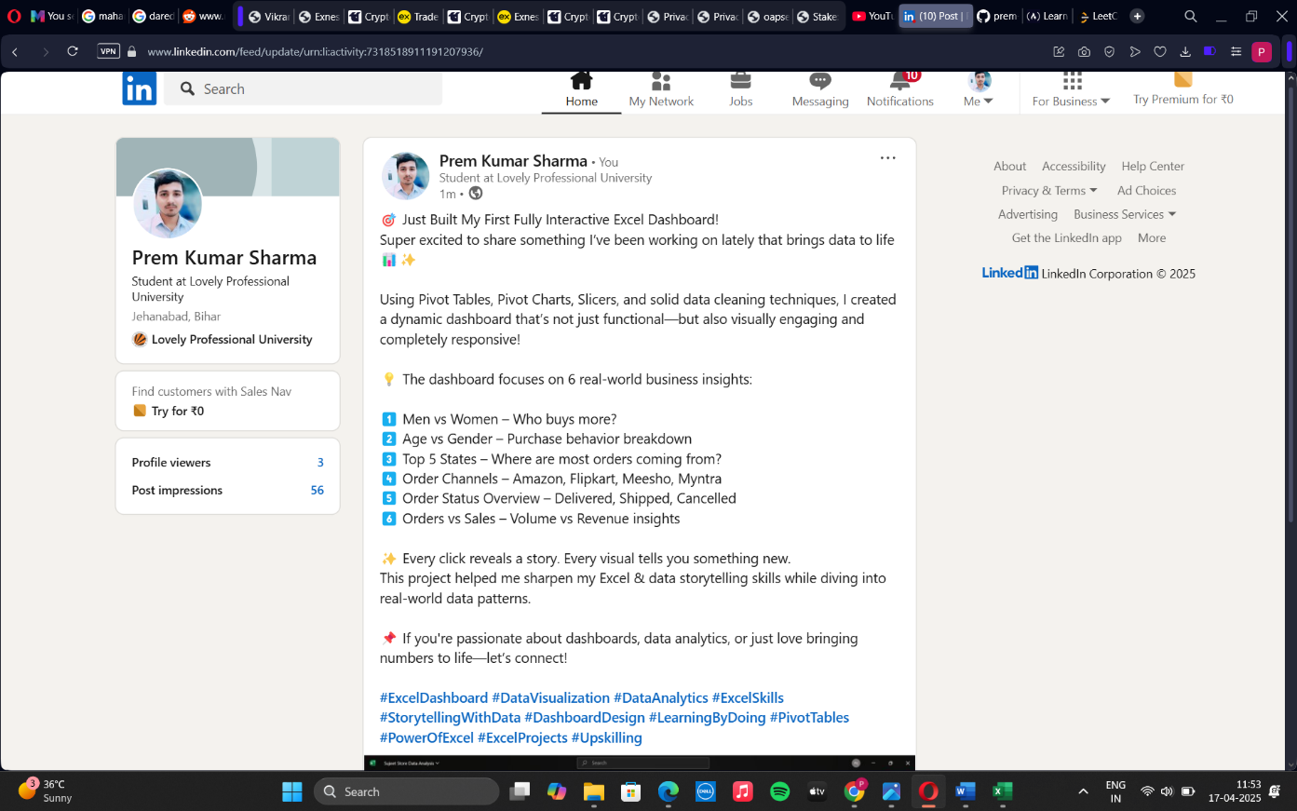

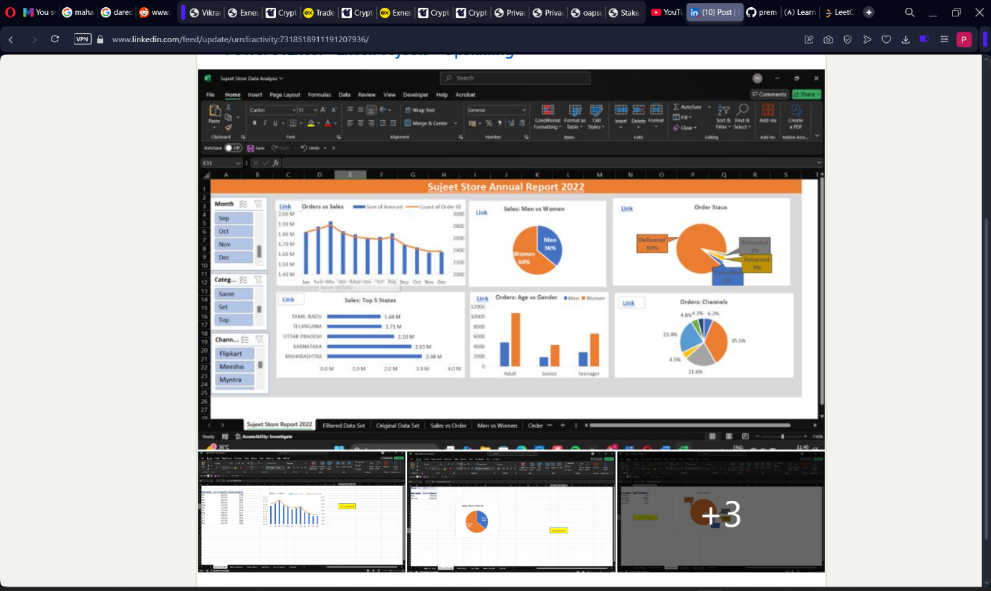

**9.Github**

**Github Profile** [**https://github.com/prem-kr-sharma**](https://github.com/prem-kr-sharma)

**Repository URL** [**https://github.com/prem-kr-sharma/ Excel-Dashboard Sujeet-Store-Sales-Analysis**](https://github.com/prem-kr-sharma/-Excel-Dashboard---Sujeet-Store-Sales-Analysis)

